Using the Portal for Password Changes
Go to https://dcfportal.dcf.ks.gov Save this site as a Favorite!
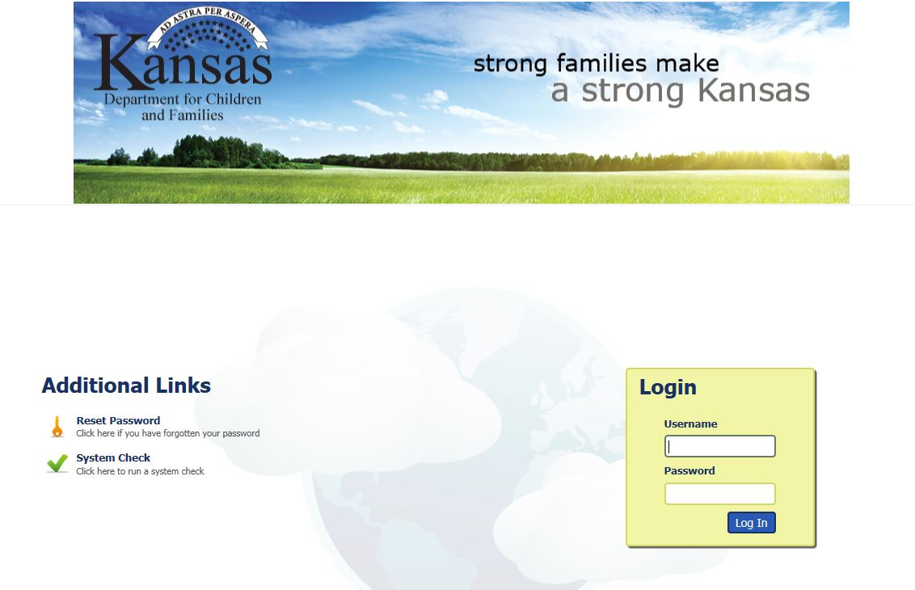
1. Logon with your DCF UPN, firstname.lastname@dcf.ks.gov.
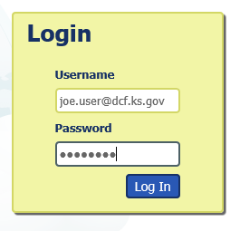
Click on Log In

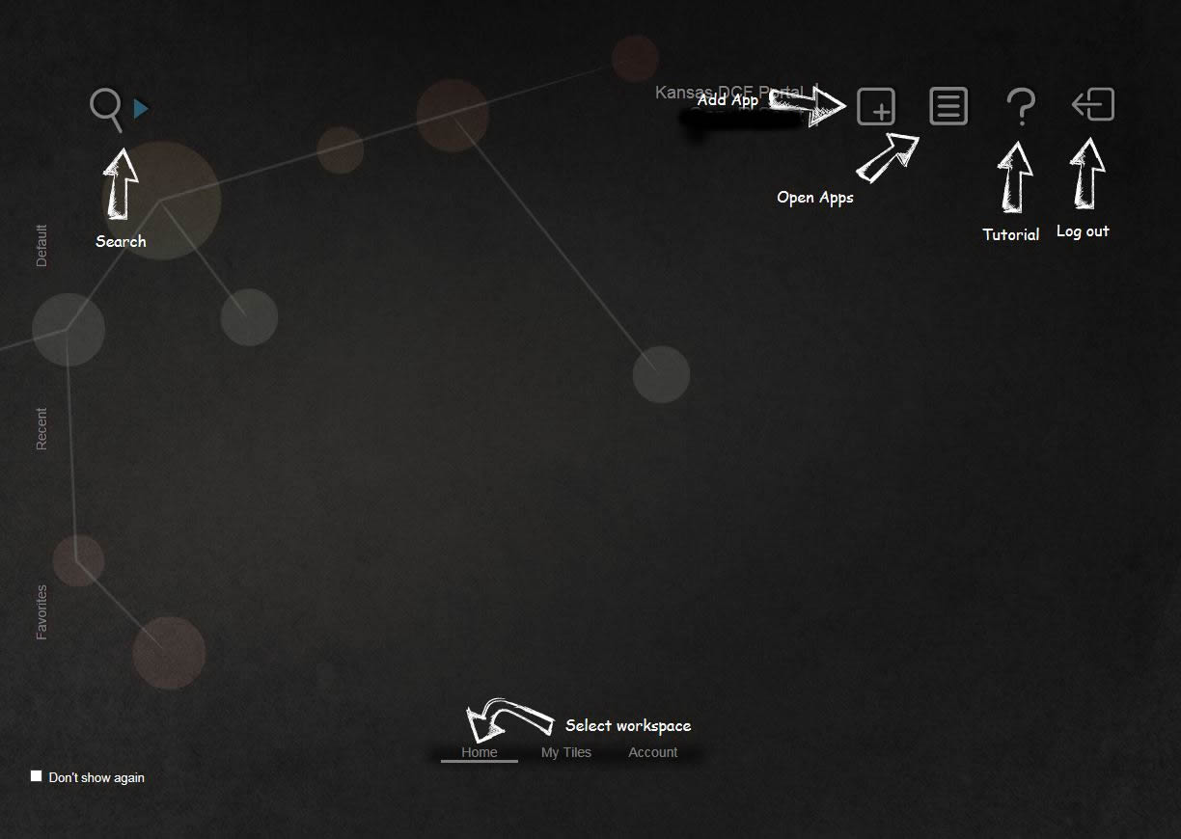
2. The first time you login, the screen shows you a help screen overlaid on the page. In the lower left corner, you can click on “Don’t show again” to turn it off.

Now, let’s set up our configuration so that we can use the Portal to change or reset our password.

NOTE: It is important to remember that you must setup your challenge questions BEFORE you have forgotten your password. Otherwise, call DCF Service Desk for assistance, 785/296-4999.

3. Toward the bottom of the page, click on the Account workspace.
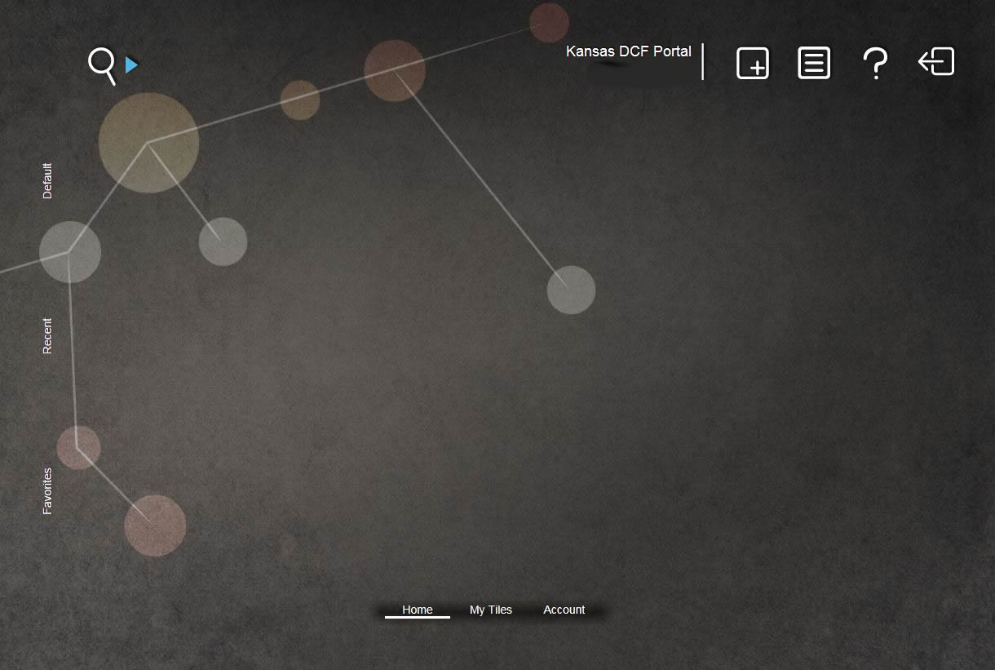

The red and yellow tiles will appear. Click on the yellow Password Challenge tile.
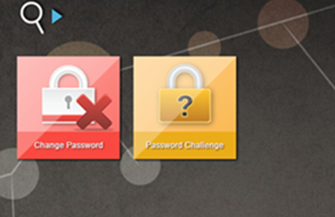

4. A Password Reset Configuration window will open up with a list of Challenge Questions.
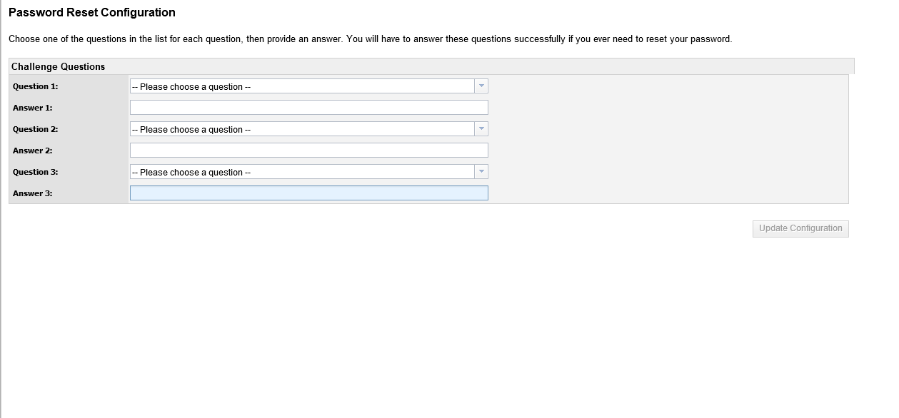
Choose a question from each drop down list and answer it accordingly. Once complete, click the Update Configuration button.
After you see the notification that your configuration saved, you can close the window that opened for this process by clicking on the “X” in the upper right corner

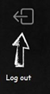
Sign out of the portal by clicking on the Log Out icon.

Now that you’ve setup your password challenge questions, you can reset your password from the initial page at https://dcfportal.dcf.ks.gov.

5. Click the Reset Password link.

6. When prompted for your Identity, it is your DCF UPN credentials. As with a normal login, you don’t need to enter the domain here. Click Next.
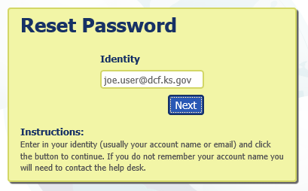

7. After entering your Identity, you’ll be shown a CAPTCHA image and you must enter the characters. They are case sensitive. If you cannot read the characters presented, click on the Change Characters link under the image to generate new ones. This CAPTCHA tool is used to prevent automated accounts from breaking in to the system.
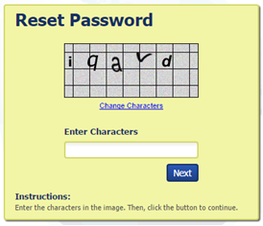
8. You’ll then be prompted to answer the challenge questions you setup initially.

9. After successfully answering the questions you can provide a new password.

Monthly Password Change
If a user needs to change their password and not reset it due to forgetting it, they can use the red Change Password tile that is also found in the Account workspace. The Password Challenge questions do not need to be setup in order to use the Change Password feature.
Your password should be 12 characters and include one uppercase letter, one number and one special character.
